Design Specification

DS

System: X10

Subsystem MM

Table of Contents:
Contents
Design Specification 1
1 Introduction 2
2 Procedure and function overview 2
3 Definitions and abbreviations 2
4 Implementation Description 2
4.1 BE05WE10CT User exit for 3-way check 3
4.2 BE05WE10CT BADI to save data into the index table 4
4.3 BE05WE10CT Class ZCL_MM_COI3WC_MIGO_SAVE 5
4.4 BE05WE10CT Class ZCL_MM_COI_UTILITY 6
4.5 BE05WE10CT Class ZCL_IM_C_COI_INDEX 9
4.6 BE05WE10CT Class ZCL_MM_COI3WC_CONFIG 9
4.7 BE05WE10CT Class ZCL_MM_COI3WC_ISO7064_CHKSUM 10
4.8 BE05WE10CT Class ZCL_PP_COI_INDEX 11
4.9 BE05WE10CT 3-way check configuration tables 12
4.10 PR18COI Screen SAPLXCO1 - 9002 15
4.11 PR18AE24COI BADI WORKORDER_UPDATE implementation 15
4.12 PR18PM13COI BADI MB_MIGO_ITEM_BADI implementation 16
4.13 PR18PM13COI BADI WORKORDER_GOODSMVT implementation 17
4.14 VE02CS14 Screen SAPMV45A - 8309 17
4.15 VE02CS14 Sales Order user exits 18
4.16 QM99ZZ Report ZMR_CHAIN_OF_IDENTITY 19
4.17 VE13OP Delivery output 22
4.18 VE02SH03 Outbound Delivery User Exits 23
4.19 WM01AT /VE02SH03 Automatic Batch Determination 23
4.20 WM01AT Transfer Order Batch Check 24
5 Related Documents 25
6 History 25

Introduction
In order to guarantee the chain of identity there is a need to have the chain of identity field in all of the documents involved in the apheresis process.
<<< Description of the system, methods and tools, short overview over the main chapters. >>>

Procedure and function overview
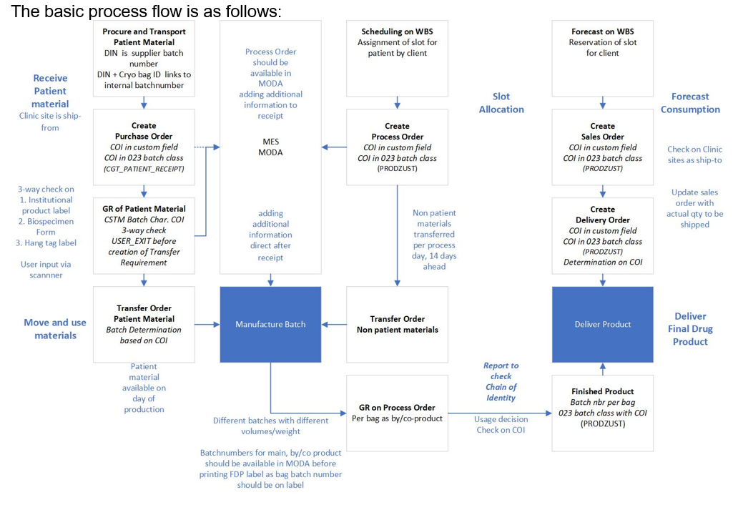
<<< high level description of the procedures and functions implemented in the system. Use Graphical descriptions (e.g. flow chart) if possible. >>>

Definitions and abbreviations
For purposes of this document, definitions and abbreviations given in CORP-24, “Lonza Glossary” and GROUP-222, “Glossary for Corporate IT Computer System” apply. For specific definitions and explanations of the different Design Specification sections, refer to the GROUP-155, “SOP Design Specifications for Computerized Systems”

Implementation Description
The developments related to the implementation of Chain of Identity consists of 6 main parts
- 3-way check at Goods Receipt for Purchase Order
- Storing and controlling Chain of Identity numbers in Process Orders, Produced Batches and Goods Receipt and Goods Issue for Process Order
- Creating Warehouse Transfer order for Process Order: automatic batch determination with COI control and checking Batch COI against Process Order COI
- Batch determination for Sales Orders. Storing COI in Sales Order. Controlling batch COI against Sales Order COI. Preventing creation of Outbound Delivery against a Sales Order without correct batch
- Detailed report of Chain of Identity usage
- Printing of Chain of Identity number on Delivery Printout
The actual development consist of
- several custom screens (for Process Order and Sales Order),
- user exits, BADI implementations and Copy Control routines,
- lot of utility classes
- one report program
The different user exit and BADI activations are checked by parameters in table ZVV_PARAM.
The following parameters are used:
LOOKUP_NAME | VKORG | VTWEG | SPART | FREE_KEY | VALUE1 | Information
ZMM_COI_3WAYCHECK | N/A | N/A | N/A | PORG | List of purchasing organizations | For 3-way check
ZMM_COI_3WAYCHECK | N/A | N/A | N/A | ATWRT | Material hazardous class (list of) | Used in every place to check material relevancy
ZPP_COI_PRORD | N/A | N/A | N/A | WERKS_D | Plant list | Process order relevancy
ZPP_COI_PRORD | N/A | N/A | N/A | PI_AUFART | Order type list | Process order relevancy
ZWM_COI_PRORD | N/A | N/A | N/A | LGNUM | Warehouse list | Transfer Order relevancy
ZWM_COI_PRORD | N/A | N/A | N/A | BWLVS | Warehouse movement types | Transfer Order relevancy
ZSD_COI_SO | Sales organization | Distribution channel | Division | AUART | Sales document types | Sales Order and Delivery relevancy
- The values always must be maintained in the VALUE1 field (other value fields are not taken into account)
- Any number of table records can be created with the same keys
- The values in field VALUE1 can be separated with anything (space, comma, etc.)

BE05WE10CT User exit for 3-way check
<<< Detail explanation of the technical flow including all relevant objects.>>>

Other information:
N/A

Security setup / Access permissions
  - SAP standard MIGO authorization
  - Configuration in ZVV_PARAM table

Data Organization / Performance considerations
N/A

Interface technical details
N/A

Quality technical details
N/A

Configuration details
The user exit is executed at material document posting, when a new batch is to be generated.
User exit | MBCFC004
Function module | EXIT_SAPMM07M_004 - Customer Function Call: Dynamic Characteristic Value Assgmt for Batches
FM include | ZXMBCU04
Include | ZM_COI3WC_ZXMBCU04

Processing logic in the include:
- Check that it is executed only once (the user exit is executed every time the user presses the “Check” or the “Post” button)
- Call method ZCL_MM_COI3WC_MIGO_SAVE→EXECUTE
- Fill the received characterisitcs into the user exit communication table (“VALUES”)
- In case a message was returned, trigger the message

BE05WE10CT BADI to save data into the index table
<<< Detail explanation of the technical flow including all relevant objects.>>>

Other information:
N/A

Security setup / Access permissions
  - SAP standard MIGO authorization
  - Configuration in ZVV_PARAM table

Data Organization / Performance considerations
N/A

Interface technical details
N/A

Quality technical details
N/A

Configuration details
The BADI is executed during material document posting in background task
BADI | MB_DOCUMENT_BADI
Implementation | ZC_COI_INDEX
Implementing class | ZCL_IM_C_COI_INDEX
Method | MB_DOCUMENT_UPDATE

Processing logic in the include:
  - Loop on the document header and items which contain material and batch
  - Get the batch COI and DIN number using ZCL_MM_COI_UTILITY=>GET_BATCH_INFORMATION
  - Save into the index table using ZCL_PP_COI_INDEX=>SAVE_INDEX_WRAPPER in normal execution mode.

BE05WE10CT Class ZCL_MM_COI3WC_MIGO_SAVE
<<< Detail explanation of the technical flow including all relevant objects.>>>

Other information:
N/A

Security setup / Access permissions
N/A

Data Organization / Performance considerations
N/A

Interface technical details
N/A

Quality technical details
N/A

Configuration details
Method EXECUTE:
- Check whether the 3-way check is needed or not (ZCL_MM_COI_UTILITY=>CHECK_COI_NEEDED_GR)
- If it’s a goods movement for Process Order;
  - Get the COI number of the batch (ZCL_MM_COI_UTILITY=>GET_BATCH_INFORMATION)
  - If the Process Order COI is not the same as the Batch COI, issue error message
- If it’s a goods receipt for Purchase Order:
  - Get the 3-way check configuration (ZCL_MM_COI3WC_CONFIG=>GET_CONFIGURATION)
  - In case of error
    - notify the user (method POPUP_CONFIG_ERROR)
    - prepare the characteristics for unsuccessful 3-way check (method PREPARE_RETURN)
    - finish
  - Ask the user if wants to execute the 3-way check (method POPUP_USER_WANTS_3WAY_CHECK)
  - If no, prepare characteristics for unsuccessful 3-way check and finish
  - LOOP on the defined screens
    - Process the screen (ZCL_MM_COI_UTILITY=>PROCESS_SCREEN)
    - If the user cancelled the execution, prepare characteristics for unsuccessful 3-way check and finish
  - Finally check all the inputs (ZCL_MM_COI_UTILITY=>FINAL_CHECK_INPUT)
  - If unsuccessful, ask the user if wants to cancel (method POPUP_UNSUCCESSFUL). If cancelled, prepare 3-way check unsuccessful characteristics and finish. If not cancelled, return to the current screen with message.
  - If successful, prepare all batch characteristics from the input data, + 3-way check successful characteristic and finish
Method PREPARE_RETURN
- If configuration error, return an error message
- If user cancellation, popup (ZCL_MM_COI_UTILITY=>POPUP_FOR_USER_CANCEL). If the user wants to finish the complete posting, leave MIGO transaction. Otherwise return with an error message, so the user can continue.
- Create the characteristic “CGT_3WAY” with “YES” or “NO” depending on the 3-way check was successful or not
- Create all the required characteristics based on the configuration
- Save the link record (method SAVE_LINK)
Method ADD_CHARACTERISTIC
- Create a characteristics line with method CREATE_VALUES_LINE
- If the given characteristic exists already, just update the value. Otherwise create as new characteristic.
Method CREATE_VALUES_LINE
- Get the internal number (ATINN) of the characteristic (ATNAM) from table CABN
- Prepare a line with ATINN and ATNAM
Method POPUP_CONFIG_ERROR
- Prepare popup title (“3-way check configuration error”) and text (“For material &1 no configuration exist”)
- Call ZCL_MM_COI_UTILITY=>POPUP_CONFIRMATION
Method POPUP_USER_WANTS_3WAY_CHECK
- Prepare popup title (“3-way check is necessary”) and text (“Please proceed with 3-way check!”)
- Call ZCL_MM_COI_UTILITY=>POPUP_CONFIRMATION
Method POPUP_UNSUCCESSFUL
- Prepare popup title (“3-way check failed”) and text (“3-way check failed. Do you want to repeat?”)
- Call ZCL_MM_COI_UTILITY=>POPUP_CONFIRMATION
Method SAVE_LINK
- Prepare database ID “ZZZZCOIMEM” + user name
- Get the COI number from characteristic “CGT_COI_BDF”
- Prepare an internal table entry with MATNR, CHARG and COI and save into database with the previously prepared ID

BE05WE10CT Class ZCL_MM_COI_UTILITY
<<< Detail explanation of the technical flow including all relevant objects.>>>

Other information:
N/A

Security setup / Access permissions
N/A

Data Organization / Performance considerations
N/A

Interface technical details
N/A

Quality technical details
N/A

Configuration details
Method CHECK_COI_NEEDED_TR
- Check that the warehouse number (IV_LGNUM) is in the ZVV_PARAM customizing
- Check that the warehouse movement type is in the ZVV_PARAM customizing
- If both yes, return TRUE, otherwise FALSE.
Method FINAL_CHECK_INPUT
- Compare every screen-pairs (so in case we have total 3 screens, it compares 1 with 2, then 1 with 3, then 2 with 3)
- Compare the same fields on the two screens (same TABNAME and FIELDNAME)
- If the value is different, return as unsuccessful
- Also checks that all obligatory fields has something value
Method GET_MATERIAL_INFORMATION
- Get the material characteristics using FM “CLAF_CLASSIFICATION_OF_OBJECTS”
- Tries to find the characteristic “NL_HAZARDOUS_CLASS”, and if found, return its value – otherwise return empty.
Method CHECK_COI_NEEDED_MATNR
- Get the hazardous class (method GET_MATERIAL_INFORMATION)
- Check that the material hazardous class is defined in ZVV_PARAM
Method CHECK_COI_NEEDED_GR
- Get material hazardous class (method GET_MATERIAL_INFORMATION)
- Get the purchasing organization if ti’s a goods receipt for purchase order
- Get the process order COI number (AUFK-ZZCOI) if it’s a goods movement for process order
- If it’s for process order and process order has COI number, check that the movement type is correct (method GET_BWART_RANGES)
- Call method CHECK_COI_NEEDED_GR_INT with the collected information
Method PROCESS_SCREEN
- DO until the screen successfully processed or the user cancelled:
  - Prepare parameters for input data for standard SAP popup (method CONVERT_FIELDLIST_TO_SVALS)
  - Call function “POPUP_GET_VALUES”
  - Convert back (method CONVERT_SVALS_TO_FIELDLIST)
  - Check that all obligatory fields filled. If not, return to the input screen with error message
  - Check that the entered COI is not duplicate
  - Check that the entered DIN is not duplicate
  - Display results. For the result calculate and display checksum (ISO7064) using ZCL_MM_COI3WC_ISO7064_CHKSUM=>CALCULATE
Method POPUP_FOR_USER_CANCEL
- Prepare popup title (“3-way check cancelled”) and text (“Do you wish to cancel Goods Receipt process?”)
- Call FM “POPUP_TO_CONFIRM”
Method POPUP_CONFIRMATION
- Call FM “POPUP_TO_CONFIRM” with the input parameters
Method GET_ATINN
- Select ATINN from CABN for the required ATNAM
Method CHECK_COI_NEEDED_PO
- Get material hazardous class (method GET_MATERIAL_INFORMATION)
- Check that the hazardous class is in the ZVV_PARAM configuration
- Check that the process order type is in the ZVV_PARAM configuration
- Check that the processing plant is in the ZVV_PARAM configuration
Method POPUP_CHECK_COI_CHECKSUM
- Calculate checksum (ZCL_MM_COI3WC_ISO7064_CHKSUM=>CALCULATE)
- Prepare popup title and text
- call FM “POPUP_TO_DECIDE_INFO”
Method GET_BATCH_INFORMATION
- Prepare database ID
- Check if the batch exists in database
- If no:
  - Try to get the information from the database ID
  - If found, return the corresponding COI and DIN, if not, then return empty
- If yes:
  - Get the batch characteristics (ZCL_COMMON_UTILITY=>BATCH_CHAR_READ)
  - Try to find the COI and DIN in the characteristics
  - If not found, try from database ID
  - Return the found COI and DIN
Method GET_BWART_RANGES
- Add movement type “101” for purchase order, movement type “101” and “261” for process order
Method UPDATE_BATCH_COI_DIN
- Call FM “ZPP_COI_UPDATE_BATCH” or “ZPP_COI_UPDATE_BATCH_UPDATE”according to the selected method
  - IN BACKGROUND TASK
  - IN UPDATE TASK
  - normal
Method CHECK_COI_NEEDED_SO
- Select from ZVV_PARAM with LOOKUP_NAME = “ZSD_COI_SO”, with the sales organization, distribution channel, division and order type
- If found, return TRUE, otherwise FALSE
Method GET_COI_FOR_DELIVERY
- Select the preceding Sales Order numbers for the Delivery from table VBFA
- For all found Sales Orders return a list of the COI numbers (VBAK-ZZCOI)
Method BATCH_SELECTION
- Check that the material is relevant (method CHECK_COI_NEEDED_MATNR)
- If the batch is to be found for process order:
  - Check that the Transport request is relevant (method CHECK_COI_NEEDED_TR)
  - Get the process order COI number (AUFK-ZZCOI)
- If the batch is to be found for Delivery:
  - Try to get global variable LIPS-VGBEL of program SAPFV50D from the call stack
  - If successful:
  - Get sales order header from VBAK
  - Check that sales order is relevant with ZCL_MM_COI_UTILITY=>CHECK_COI_NEEDED_SO
  - If yes, the COI number to restrict is VBAK-ZZCOI
- If so far ok (relevant and the main document has COI number), create filter criteria for batch determination with the COI number
Method CHECK_SO_OD_BATCH
- Get the COI number (either supplied, or from the Sales order, or from the Sales order of the delivery)
- Check that the material is relevant (method CHECK_COI_NEEDED_MATNR)
- If batch is given:
  - Get the batch COI number (method GET_BATCH_INFORMATION)
  - If the header COI is deifferent from the batch COI, issue error message
- If no batch, and the document is Delivery, also issue error message
Method CHECK_PO_BATCH_FOR_TO
- Get the process order COI (AUFK-ZZCOI for LTAK-BENUM=AUFNR)
- Check that the transfer requirement is relevant (method CHECK_COI_NEEDED_TR)
- Check that the material is relevant (method CHECK_COI_NEEDED_MATNR)
- Get the batch COI number (method GET_BATCH_INFORMATION)
- If the process order COI different from the batch COI, issue error message
Method CHECK_COI_NEEDED_GR_INT
- If for process order, and process order has no COI, return as irrelevant
- Check purchase order purchasing organization against the configuration
- Check material hazardous class against the configuration
Method CONVERT_FIELDLIST_TO_SVALS
- If there was a message, create a 1st line with the message text
- Create a line for every field on the screen (edit or display)
Method CONVERT_SVALS_TO_FIELDLIST
- Remove the message line
- Create a new field line for every field

BE05WE10CT Class ZCL_IM_C_COI_INDEX
<<< Detail explanation of the technical flow including all relevant objects.>>>

Other information:
N/A

Security setup / Access permissions
N/A

Data Organization / Performance considerations
N/A

Interface technical details
N/A

Quality technical details
N/A

Configuration details
Method MB_DOCUMENT_UPDATE
- Loop on the document headers (XMKPF) and items (XMSEG)
- Get the batch COI and DIN (ZCL_MM_COI_UTILITY=>GET_BATCH_INFORMATION)
- Create index table entry
- Call ZCL_PP_COI_INDEX=>SAVE_INDEX_WRAPPER to save

BE05WE10CT Class ZCL_MM_COI3WC_CONFIG
<<< Detail explanation of the technical flow including all relevant objects.>>>

Other information:
N/A

Security setup / Access permissions
N/A

Data Organization / Performance considerations
N/A

Interface technical details
N/A

Quality technical details
N/A

Configuration details
Method GET_CONFIGURATION
- Get the configuration according to the material number from table ZMM_COICONF_MATN
- If not found, select the “DEFAULT” configuration from table ZMM_COICONF_CONF
- If even that not found, return with error
- Get the screens of the configuration from table ZMM_COICONF_CFSC
- Get the screen data fro table ZMM_COICONF_SCRN
- Get the fields of the screen from table ZMM_COICONF_SCFL
- Get the field details from table ZMM_COICONF_FLDS
- Compose the complete configuration into table type ZMM_COI3WC_CONF_SCREEN_TT

BE05WE10CT Class ZCL_MM_COI3WC_ISO7064_CHKSUM
<<< Detail explanation of the technical flow including all relevant objects.>>>

Other information:
N/A

Security setup / Access permissions
N/A

Data Organization / Performance considerations
N/A

Interface technical details
N/A

Quality technical details
N/A

Configuration details
Method CALCULATE
- Get the input length, if 0, error
- Check the input (method CHECK_INPUT)
- Do the calculation according to the ISO7064 standard
Method CHECK_INPUT
- Check that the input contains only allowed characters: 0123456789ABCDEFGHIJKLMNOPQRSTUVWXYZ*
Method GET_CHECK_VALUE
- Find the position of the requested character in the control text
- If found, return its position, otherwise 99 (as error)

BE05WE10CT Class ZCL_PP_COI_INDEX
<<< Detail explanation of the technical flow including all relevant objects.>>>

Other information:
N/A

Security setup / Access permissions
N/A

Data Organization / Performance considerations
N/A

Interface technical details
N/A

Quality technical details
N/A

Configuration details
Method SAVE_INDEX_WRAPPER
- If background task was requested, call FM “ZPP_COI_SAVE_INDEX” in background task, which calls back method SAVE_INDEX
- If update task was requested, call FM “ZPP_COI_SAVE_INDEX_UPDATE” in update task, which calls back method SAVE_INDEX
- Otherwise call directly method SAVE_INDEX
Method SAVE_INDEX
- Handle existing records: if a record for the same process order or sales order existed just with a different COI number, set its “deleted” flag and deleting user and date
- Save new record into table ZPP_COI_INDEX
Method SAVE_SALES_ORDER
- Create header index record calling method SAVE_INDEX_WRAPPER
- For all items create a separate record with the same method

Table ZPP_COI_INDEX - Index table for Chain of Identity
The purpose of this table is to
- make a fast possibility to find batches, sales orders and process orders based on COI number, because otherwise all these searches would be too slow for reporting
- also to check duplicate COI and DIN numbers
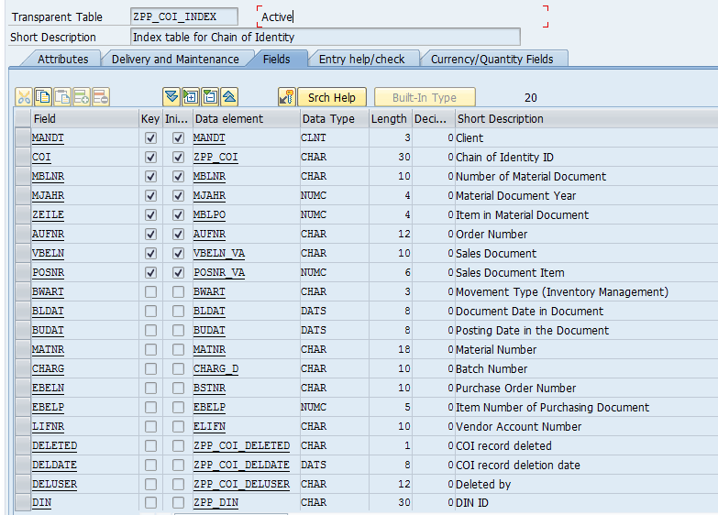
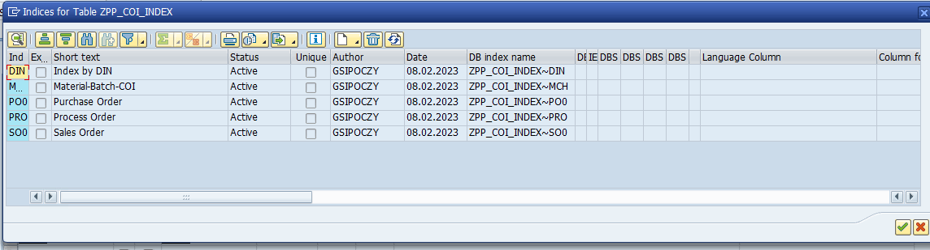

BE05WE10CT 3-way check configuration tables
<<< Detail explanation of the technical flow including all relevant objects.>>>

Other information:
N/A

Security setup / Access permissions
N/A

Data Organization / Performance considerations
N/A

Interface technical details
N/A

Quality technical details
N/A

Configuration details
Configuration tables and maintenance transactions
Table | Description | Transaction code
ZMM_COICONF_MATN | COI configuration: Assign configuration to material | ZM_COICONF_MATN
ZMM_COICONF_CONF | COI configuration: Configurations | ZM_COICONF_CONF
ZMM_COICONF_CFSC | COI configuration: Configuration screens | ZM_COICONF_CFSC
ZMM_COICONF_SCRN | COI configuration: Screens | ZM_COICONF_SCRN
ZMM_COICONF_SCFL | COI configuration: Screen fields | ZM_COICONF_SCFL
ZMM_COICONF_FLDS | COI configuration: Fields | ZM_COICONF_FLDS

Table ZMM_COICONF_MATN

Field | Key | Data element | Data type | Size | Description
MANDT | X | MANDT | CLNT | 3 | Client
MATNR | X | MATNR | CHAR | 18 | Material Number
CONFIG |  | ZM_COICONF_CONF_ID | CHAR | 10 | COI configuration: Configuration ID

Table ZMM_COICONF_CONF

Field | Key | Data element | Data type | Size | Description
MANDT | X | MANDT | CLNT | 3 | Client
CONFIG | X | ZM_COICONF_CONF_ID | CHAR | 10 | COI configuration: Configuration ID
TEXT |  | ZM_COICONF_TEXT | CHAR | 50 | COI configuration: Description

Table ZMM_COICONF_CFSC

Field | Key | Data element | Data type | Size | Description
MANDT | X | MANDT | CLNT | 3 | Client
CONFIG | X | ZM_COICONF_CONF_ID | CHAR | 10 | COI configuration: Configuration ID
ORDERNUM | X | ZM_COICONF_ORDER | NUMC | 2 | COI configuraion: Order
SCREEN |  | ZM_COICONF_SCR_ID | CHAR | 10 | COI configuration: Screen ID

Table ZMM_COICONF_SCRN

Field | Key | Data element | Data type | Size | Description
MANDT | X | MANDT | CLNT | 3 | Client
SCREEN | X | ZM_COICONF_SCR_ID | CHAR | 10 | COI configuration: Screen ID
TEXT |  | ZM_COICONF_TEXT | CHAR | 50 | COI configuration: Description

Table ZMM_COICONF_SCFL

Field | Key | Data element | Data type | Size | Description
MANDT | X | MANDT | CLNT | 3 | Client
SCREEN | X | ZM_COICONF_SCR_ID | CHAR | 10 | COI configuration: Screen ID
ORDERNUM | X | ZM_COICONF_ORDER | NUMC | 2 | COI configuraion: Order
FIELD |  | ZM_COICONF_FLD_ID | CHAR | 10 | COI configuration: Field ID
ATNAM |  | ATNAM | CHAR | 30 | Characteristic Name
OBLIGATORY |  | ZM_COICONF_OBLIGATORY | CHAR | 1 | COI configuration: Obligatory field

Table ZMM_COICONF_FLDS

Field | Key | Data element | Data type | Size | Description
MANDT | X | MANDT | CLNT | 3 | Client
FIELD | X | ZM_COICONF_FLD_ID | CHAR | 10 | COI configuration: Field ID
TEXT |  | ZM_COICONF_TEXT | CHAR | 50 | COI configuration: Description
CHECKSUM |  | ZM_COICONF_CHKSUM | CHAR | 1 | COI configuration: Field with checksum?

PR18COI Screen SAPLXCO1 - 9002
<<< Detail explanation of the technical flow including all relevant objects.>>>

Other information:
N/A

Security setup / Access permissions
N/A

Data Organization / Performance considerations
N/A

Interface technical details
N/A

Quality technical details
N/A

Configuration details
This custom screen is used at Process Order maintenance to enter COI number.
The screen has only one field: AUFK-ZZCOI (the field was added to table extension structure CI_AUFK)
PBO logic:
- Check whether the PO is relevant (ZCL_MM_COI_UTILITY=>CHECK_COI_NEEDED_PO)
- If not: set the field invisible
- If yes: set visible, editable in COR1/2, display in COR3
PAI logic:
- Check that the COI was changed compared to the previous screen run to avoid multiple handling
- Display Pop-up with the calculated checksum (ZCL_MM_COI_UTILITY=>POPUP_CHECK_COI_CHECKSUM)
- If the user cancels (finds the checksum incorrect) clear out the COI value

PR18AE24COI BADI WORKORDER_UPDATE implementation
<<< Detail explanation of the technical flow including all relevant objects.>>>

Other information:
N/A

Security setup / Access permissions
N/A

Data Organization / Performance considerations
N/A

Interface technical details
N/A

Quality technical details
N/A

Configuration details
Implementation name: ZC_COI_PROCESS_ORDER
Implementing class: ZCL_IM_C_COI_PROCESS_ORDER
Implemented methods:
AT_SAVE:
- Execute only if AUFK-ZZCOI is empty
- Check that the PO is relevant (ZCL_MM_COI_UTILITY=>CHECK_COI_NEEDED_PO)
- Check if the PO release date is filled (PO is released) or not
- If released, give error, otherwise warning message “Please fill Chain of Identity ID!”
IN_UPDATE:
- If both AUFK-AUFNR and AUFK-ZZCOI filled:
- Create a record in the index table (ZCL_PP_COI_INDEX=>SAVE_INDEX_WRAPPER)
- Update the COI number in the PO item batch characteristics (ZCL_MM_COI_UTILITY=>UPDATE_BATCH_COI_DIN)
AT_RELEASE:
- Check that the PO is relevant (ZCL_MM_COI_UTILITY=>CHECK_COI_NEEDED_PO)
- If AUFK-ZZCOI is empty, error message “Please fill Chain of Identity ID!”
- If filled, but the PO was not previously saved in database, message “Please save the order before release.”

PR18PM13COI BADI MB_MIGO_ITEM_BADI implementation
<<< Detail explanation of the technical flow including all relevant objects.>>>

Other information:
N/A

Security setup / Access permissions
N/A

Data Organization / Performance considerations
N/A

Interface technical details
N/A

Quality technical details
N/A

Configuration details
Implementation name: ZC_COI_MIGO_PO_CHECK
Implementing class: ZCL_IM_C_COI_MIGO_PO_CHECK
Implemented methods:
ITEM_MODIFY:
- Only if AUFNR, MATNR and CHARGE filled:
- Check that the posting is relevant (ZCL_MM_COI_UTILITY=>CHECK_COI_NEEDED_GR)
- Continue if relevant and AUFK-ZZCOI is filled:
- Get the batch COI number (ZCL_MM_COI_UTILITY=>GET_BATCH_INFORMATION)
- If the PO COI and the batch COI are not identical, issue error message “Process order COI &1 different from batch COI &2.”

PR18PM13COI BADI WORKORDER_GOODSMVT implementation
<<< Detail explanation of the technical flow including all relevant objects.>>>

Other information:
N/A

Security setup / Access permissions
N/A

Data Organization / Performance considerations
N/A

Interface technical details
N/A

Quality technical details
N/A

Configuration details
Implementation name: ZC_COI_COR6_PO_CHECK
Implementing class: ZCL_IM_C_COI_COR6_PO_CHECK
Implemented methods:
COMPLETE_GOODSMOVEMENT
- Only if MSEG-AUFNR, MSEG-MATNR and MSEG-CHARG is filled
- Check that the posting is relevant (ZCL_MM_COI_UTILITY=>CHECK_COI_NEEDED_GR)
- Continue if relevant and AUFK-ZZCOI is filled:
- Get the batch COI number (ZCL_MM_COI_UTILITY=>GET_BATCH_INFORMATION)
- If the PO COI and the batch COI are not identical, issue error message “Process order COI &1 different from batch COI &2.”

VE02CS14 Screen SAPMV45A - 8309
<<< Detail explanation of the technical flow including all relevant objects.>>>

Other information:
N/A

Security setup / Access permissions
N/A

Data Organization / Performance considerations
N/A

Interface technical details
N/A

Quality technical details
N/A

Configuration details
This custom screen is used at Sales Order maintenance as Header custom data B.
One field added to the screen: VBAK-ZZCOI (the field was added to table extension structure ZAVBAK). The PBO and PAI logic is in include ZZ_MV45A_COI and ZZ_MV45A_COI_F01.
PBO logic:
- Check whether the Sales Order is relevant (ZCL_MM_COI_UTILITY=>CHECK_COI_NEEDED_SO)
- If not: set the field invisible
- If yes: set visible, editable and obligatory in VA01, VA02, display in VA03
PAI logic:
- Check that the COI was changed compared to the previous screen run to avoid multiple handling
- Display Pop-up with the calculated checksum (ZCL_MM_COI_UTILITY=>POPUP_CHECK_COI_CHECKSUM)
- If the user cancels (finds the checksum incorrect) clear out the COI value

VE02CS14 Sales Order user exits
<<< Detail explanation of the technical flow including all relevant objects.>>>

Other information:
The COI number is a header information of the sales order, independently of what kind of materials it will have later. However the necessity checks are activated only if there is at least one item with a material that is COI relevant.

Security setup / Access permissions
N/A

Data Organization / Performance considerations
N/A

Interface technical details
N/A

Quality technical details
N/A

Configuration details
The implemented user exits prevent from
- saving a relevant Sales Order without header COI number (VBAK-ZZCOI)
- saving the Sales Order item with a batch having incorrect COI number
MV45AFZZ – USEREXIT_SAVE_DOCUMENT_PREPARE:
Include: ZVV_COI_MV45AFZZ_SAVE_PREP
- If VBAK-ZZCOI is filled:
  - Check that every item has the correct batch assignment (ZCL_MM_COI_UTILITY=>CHECK_SO_OD_BATCH)
- If VBAK-ZZCOI is empty:
  - Check that the Sales Order is relevant (ZCL_MM_COI_UTILITY=>CHECK_COI_NEEDED_SO)
  - If yes, give error message “Please fill Chain of Identity ID!”
MV45AFZZ - USEREXIT_SAVE_DOCUMENT
Include: ZVV_COI_MV45AFZZ_SAVE
- Call function module “ZSD_COI_SO_SAVE” in update task. This function:
- Call ZCL_PP_COI_INDEX=>SAVE_SALES_ORDER
MV45AFZB – USEREXIT_CHECK_VBAP
Include: ZVV_COI_MV45AFZB_CHECK_VBAP
- Check that the current item has the correct batch assignment (ZCL_MM_COI_UTILITY=>CHECK_SO_OD_BATCH)

QM99ZZ Report ZMR_CHAIN_OF_IDENTITY
<<< Detail explanation of the technical flow including all relevant objects.>>>

Other information:
N/A

Security setup / Access permissions
N/A

Data Organization / Performance considerations
N/A

Interface technical details
N/A

Quality technical details
N/A

Configuration details
Transaction code: ZQM_COI_REPORT
Selection screen:
Parameter/Select option | Reference | Properties
Chain of Identity number | aufk-zzcoi | NO INTERVALS
Production Plant | aufk-werks | OBLIGATORY
Material | Mara-matnr
Batch | mch1-charg
Inspection LOT | Qals-prueflos
Purchase Order | Ekko-ebeln
Process Order | Aufk-aufnr
Sales Order | Vbak-vbeln
Delivery | Likp-vbeln
Sold-to party | Vbak-kunnr | NO-EXTENSION NO INTERVALS
Ship-to party | Likp-kunnr | NO-EXTENSION NO INTERVALS
Patient Material Type | Mara-mtart | OBLIGATORY
Finished Good Material Type | Mara-mtart | OBLIGATORY

Processing logic:
- Check selections: at least one of the following must be filled:
  - COI number
  - Material
  - Batch
  - Inspection LOT
  - Purchase Order
  - Process Order
  - Sales Order
  - Delivery
  - (+ the anyway obligatory selections)
- Get the records from the index table ZPP_COI_INDEX. The fields used for selection depends on which fields are filled on the selection screen, but in any case either selects by primary key, or by an index.
- Collect the different COI numbers selected and process them one by one:
- The report works with different type of records from the index table. First the report makes group of records based on the index record content:
  - Goods Receipt for Purchase Order
  - Goods Issue for Process Order
  - Goods Receipt for Process Order
  - Process Order without any Goods Movement
  - Sales Order header
  - Sales Order Item
- Now processes the groups in 4 steps:

- Goods receipts for Purchase Order
  - Get batch information:
    - COI number
    - DIN number
    - PO Release status
    - PO Completion date
    - PO Completion time
    - COI from BDF form
    - Expiry date
    - COI of Finished Good
    - Bacth stock from MSPR project stock
  - Get material type
  - Get the inspection LOT
  - If the batch has no corresponding Goods Issue for Process Order record, add to the ALV list.
  - Otherwise start to process the Goods Issue records:
    - Get the production plant
    - Get the Process Order statuses
    - Add the lines to the ALV list
- Finished Goods – Goods Receipt for Process Order records
  - Get production plant
  - Get batch details (see above)
  - Get material type
  - Get inspection lot
  - Get process order statuses
  - If the batch has no corresponding Sales Order item, add to the ALV list
  - Otherwise process the Sales Order Item records:
    - Get the sales order status
    - Get the deliveries of the sales order item. If not found, add the line to the ALV list.
    - Otherwise create line for every delivery
      - Get the delivery status
      - Add the sold-to and ship-to party
      - append to the ALV list
- Add the remaining Process Order lines that had to Goods Receipt and so were not processed earlier
- Add the remaining Sales Order lines that were not processed earlier
After processing all COI numbers with the above 4 steps, sort the ALV list and delete the duplicates.

ALV display:
Field | On click (hotspot) display by transaction
Chain of Identity
Material | MM03
Material description
Material Type
Batch | MSC3N
DIN
Release status
Receipt Complete Date
Receipt Complete Time
COI Id from BDF
Expiration date
Chain of Identity Drug Product
Patient ID from BDF
Cryo bag id from IBL
Collection Center IBL
DIN from IBL
SEC part 1- DIS Nbr
Unrestricted Stock
QA Stock
Blocked Stock
Tot.Restr. Stock
UOM
Purchase Order
Vendor
Purchase Order Date
Inspection Lot
Process Order | COR3
Process Order Status
Process Order User Status
Sales Order | VA03
Sales Order Status
Delivery | VL03N
Delivery Status
Delivery Goods Issue Status
Delivery Date
Ship-so Party | XD03
Sold-to Party | XD03

Toolbar Commands
Button | Transaction called for the selected line
Process Order | COR3
Sales Order | VA03
Batch | MSC3N
Doc.Process Order | COOISPI
Doc.Batch | MB51
Material Master | MM03
Inventory Overview | MB52
Batch Cockpit | BMBC

VE13OP Delivery output
<<< Detail explanation of the technical flow including all relevant objects.>>>

Other information:
N/A

Security setup / Access permissions
N/A

Data Organization / Performance considerations
N/A

Interface technical details
N/A

Quality technical details
N/A

Configuration details
The COI number, which is stored in the Sales Order, is printed on the corresponding Outbound Delivery.

Print program modification:
Class: ZCL_OFW_V_DELIVERY_DATA
Method: READ_ITEM_DATA
Logic: At the end of the processing the item, call ZCL_MM_COI_UTILITY=>GET_COI_FOR_DELIVERY and update the field LS_ITEM-ZZCOI

SmartForm modification:
SmartForm: ZOFW_V_DELIVERY_PKL_INTL
Location: Main window / TABLE1 / Main Area / ITEM_BATCH / PACKAGES_BATCH / ROW9 / CELL 35
New text item TEXT140 was created:
- Condition: LS_ITEM_LINES-ZZCOI <> SPACE
- Text: <CS>Chain of Identity:&LS_ITEM_LINES-ZZCOI&</>

VE02SH03 Outbound Delivery User Exits
<<< Detail explanation of the technical flow including all relevant objects.>>>

Other information:
N/A

Security setup / Access permissions
N/A

Data Organization / Performance considerations
N/A

Interface technical details
N/A

Quality technical details
N/A

Configuration details
The implemented user exits prevent from saving the Delivery item with a batch having incorrect COI number
MV50AFZ1 – USEREXIT_MOVE_FIELD_TO_LIPS:
Include: ZVV_COI_MV50AFZ1_CHECK_LIPS
- Call ZCL_MM_COI_UTILITY=>CHECK_SO_OD_BATCH and give error if necessary
MV50AFZ1 - USEREXIT_SAVE_DOCUMENT_PREPARE
Include: ZVV_COI_MV50AFZ1_SAVE_PREP
- Call ZCL_MM_COI_UTILITY=>CHECK_SO_OD_BATCH and give error if necessary

WM01AT /VE02SH03 Automatic Batch Determination
<<< Detail explanation of the technical flow including all relevant objects.>>>

Other information:
N/A

Security setup / Access permissions
N/A

Data Organization / Performance considerations
N/A

Interface technical details
N/A

Quality technical details
N/A

Configuration details
The enhancement for SAP’s standard automatic batch determination used in 2 places:
- WM01AT - Transfer Order creation from a Transfer Requirement with reference to a 3- Process Order
- VE02SH03- Delivery creation with reference to a Sales Order
The logic used in rather simple: we add the requirement for the batch selection, that the COI number (characteristic) in the batch must be equal to the number in Process Order or Sales Order respectively.
SAP BADI: VB_BD_SELECTION_CRITERIA
Implementation: ZC_COI_PO_BATCH_DETERMINATION
Enhancement implementation: ZC_COI_PO_BATCH_DETERMINATION
Implementing class: ZCL_IM_C_COI_PO_BATCH_DET
Method: SEL_CRIT_CHANGE
Logic:
- Call ZCL_MM_COI_UTILITY=>BATCH_SELECTION

WM01AT Transfer Order Batch Check
<<< Detail explanation of the technical flow including all relevant objects.>>>

Other information:
N/A

Security setup / Access permissions
N/A

Data Organization / Performance considerations
N/A

Interface technical details
N/A

Quality technical details
N/A

Configuration details
SAP user exit function:
- EXIT_SAPLL03A_006
- EXIT_SAPLL03A_005
- EXIT_SAPLL03A_007
Logic:
- Call ZCL_MM_COI_UTILITY=>CHECK_PO_BATCH_FOR_TO

Related Documents
FS
<<< List any documents related to this Design Specification, containing additional information or possibly sub-documents containing more details. >>>

History

Order/version | Description
1.0 | New Document

